EXPERIMENT 3: WATER JUG PROBLEM

Aim: To solve the Water Jug Problem using a simple AI approach.

Objectives:
- To understand the Water Jug Problem.
- To obtain the required amount of water using two jugs.
- To apply state-space search concepts in AI.

Algorithm:
- Fill the 4-liter jug.
- Pour water into the 3-liter jug until it is full.
- Empty the 3-liter jug.
- Pour the remaining water from the 4-liter jug into the 3-liter jug.
- Fill the 4-liter jug again.
- Pour water into the 3-liter jug until it is full.
- Now the 4-liter jug contains exactly 2 liters.
- Stop.

Flow Chart

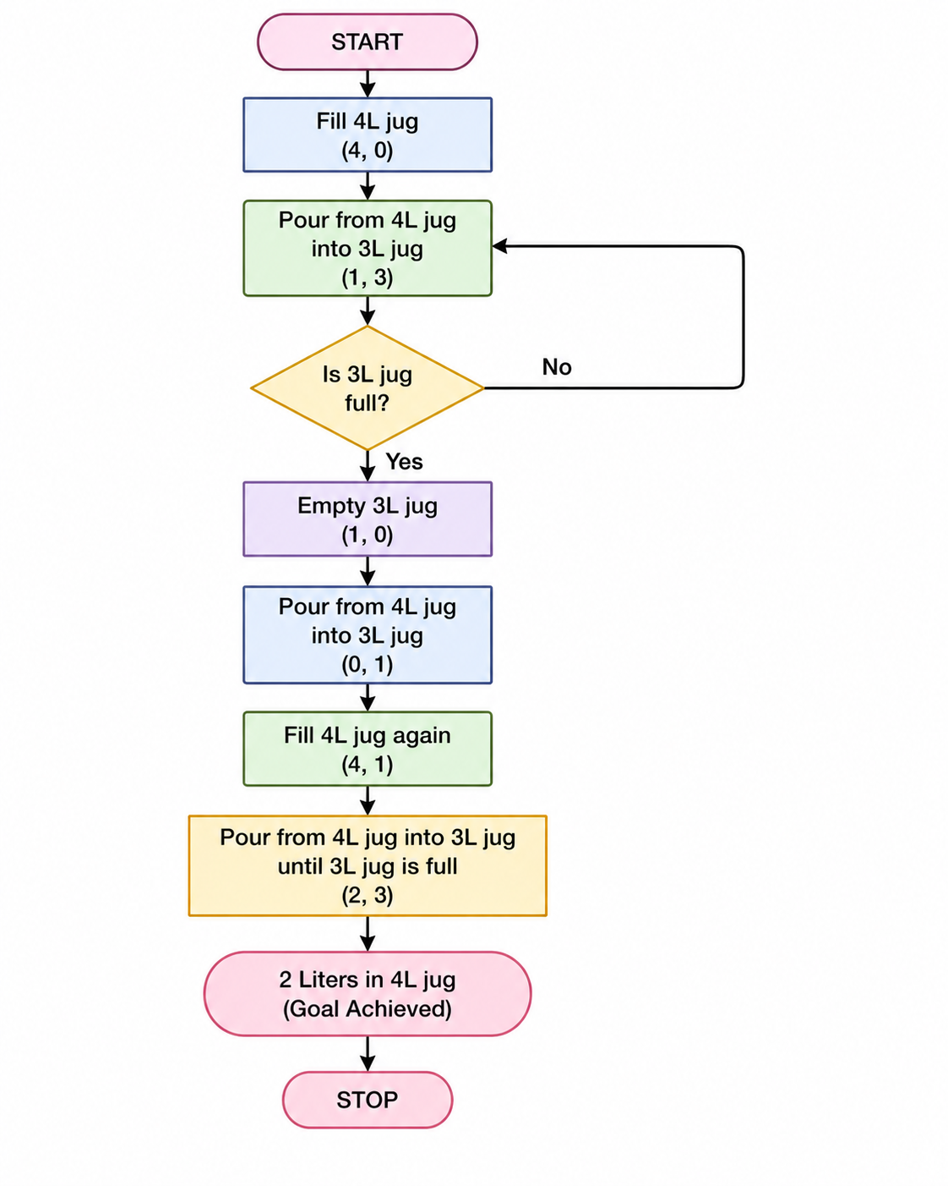

Source Code:
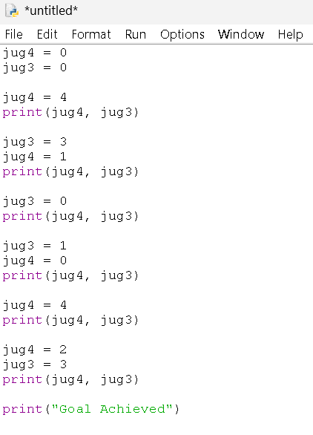
OUTPUT:

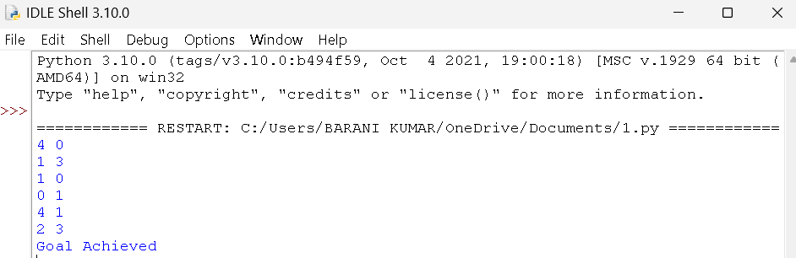

Result:
The Water Jug Problem was solved successfully, and the required 2 liters of water was obtained in the 4-liter jug.

